PSY330: M1 Assignment (40 points)

INSTRUCTION:

1. Use this Word document to type out all the answers. Each answer should be supported by the relevant SPSS output table(s), or calculation process if manual calculation was needed.
2. Download the Excel data file in Canvas for this assignment and import the data into SPSS.
3. Required documents to submit: (Include your name in all file names)
- This Word document with answers and supporting work
- SPSS data file(s) (.sav format)
- SPSS output file(s) (.spv format or exported into Word format)
Note: No grade is earned if any document is missing.
4. Review the module “Assignment Guides” for guidelines and tutorials.

Q1. Descriptive statistics with SPSS (20 points total)
Run descriptive statistics to summarize the daily high and low temperatures in Phoenix during the month of November in 2018. Use the data set in the worksheet labeled “Q1” in the file “M1 Assignment Excel Data Set” for the following questions.

A. Create an SPSS data file from the provided Excel data set, either by copying and pasting the data points into the SPSS data file or by importing the data within SPSS. The SPSS data file must show the following:
- All three variables are present in the “Data View”
- Each variable is correctly configured in “Measure” under the “Variable View”
This data file must be submitted along with your Word document to earn these points.
(3 points. Each variable = 1 point, deduct .5 point if data are incomplete/incorrect or if the variable is not correctly categorized)

B. Use SPSS to run descriptive statistics on HighTemp and LowTemp separately, in the month of November 2018. The descriptive statistics should include the following:
- Central tendency measures: Mean, median
- Dispersion (Variability) measures: Range, variance, standard deviation.
(10 points. Each answer = 2 points: 1 for the answer, 1 for the SPSS output or calculation process)
Note: Standard deviation and variance for descriptive statistics are different from standard deviation and variance estimated for a population from a sample (inferential statistics). SPSS only provides the latter while this question is asking for the descriptive statistics. See the lecture this week for the manual conversion formula.

C. Use SPSS to create a histogram for LowTemp. The histogram must display the following:
- Title of the histogram
- X and Y axes are labeled
(5 points. Deduct 1 point for missing title, missing an axis label, or incorrect data, incorrect graph type)

D. Based on the descriptive statistics and the histogram, which central tendency measure and which dispersion (variability) measure best represent the LowTemp in November 2018? Why?
(2 points. 1 for each measure chosen, deduct .5 point if a measure is chosen but the rationale is missing or incorrect.)

Q2. Interpreting and graphing descriptive statistics (10 points total)
Use the worksheet in the M1 Assignment Data Set labeled “Q2” for the following questions. The data set contains the 2017 high school graduation rates for different counties in Arizona. The graduation rate is calculated by (Number Graduated)/(Number in Cohort), which are also included in the data set.
This question should be completed in Excel so there is no need to import the data into SPSS and no need to submit an SPSS data file for this data set.

A. Examine the data and then write a paragraph (3-5 sentences) to describe the data set. The graduation rate is the main focus, but you may also comment on the other two variables. (3 points. 1 point each for describing the graduation rate, the ethnic factor, and the relationship between the two.)
Hint: Examples of things to observe: Which counties have the highest or lowest graduation rates, which counties have the highest or lowest high school cohorts in 2017, how does the cohort size affect your interpretation of the graduation rate… etc.

B. Present the graduation rate data in a graph (not a table), using Excel. The graph must display the following:
- Title of the graph
- Axis labels or legend
Note that you may need to do some editing after generating the graph to make sure you get all the points. (4 points. Deduct 1 point for missing title, missing an axis label or legend, or incorrect data)

C. Explain the rationale for your chosen type of graph. Why is your chosen graph the best way to display the data? (3 points)

Q3. Interpreting descriptive and inferential statistics (10 points)
This question set is based on the following article:

Ball, K., Berch, D. B., Helmers, K. F., Jobe, J. B., Leveck, M. D., Marsiske, M., ... & Unverzagt, F. W. (2002). Effects of cognitive training interventions with older adults: a randomized controlled trial. Jama, 288(18), 2271-2281.

A. Highlight the information in the following abstract that indicates the inferential nature of the data analysis performed in this study. Explain why it indicates inferential statistics. (2 points. 1 for highlighting appropriate info, 1 for rationale)

Abstract
Context: Cognitive function in older adults is related to independent living and need for care. However, few studies have addressed whether improving cognitive functions might have short- or long-term effects on activities related to living independently.

Objective: To evaluate whether 3 cognitive training interventions improve mental abilities and daily functioning in older, independent-living adults.

Design: Randomized, controlled, single-blind trial with recruitment conducted from March 1998 to October 1999 and 2-year follow-up through December 2001.

Setting and Participants: Volunteer sample of 2832 persons aged 65 to 94 years recruited from senior housing, community centers, and hospital/clinics in 6 metropolitan areas in the United States.

Interventions: Participants were randomly assigned to 1 of 4 groups: 10-session group training for memory (verbal episodic memory; n = 711), or reasoning (ability to solve problems that follow a serial pattern; n = 705), or speed of processing (visual search and identification; n = 712); or a no-contact control group (n = 704). For the 3 treatment groups, 4-session booster training was offered to a 60% random sample 11 months later.

Main Outcome Measures: Cognitive function and cognitively demanding everyday functioning.

Results: Thirty participants were incorrectly randomized and were excluded from the analysis. Each intervention improved the targeted cognitive ability compared with baseline, durable to 2 years (P<.001 for all). Eighty-seven percent of speed-, 74% of reasoning-, and 26% of memory-trained participants demonstrated reliable cognitive improvement immediately after the intervention period. Booster training enhanced training gains in speed (P<.001) and reasoning (P<.001) interventions (speed booster, 92%; no booster, 68%; reasoning booster, 72%; no booster, 49%), which were maintained at 2-year follow-up (P<.001 for both). No training effects on everyday functioning were detected at 2 years.

Conclusions: Results support the effectiveness and durability of the cognitive training interventions in improving targeted cognitive abilities. Training effects were of a magnitude equivalent to the amount of decline expected in elderly persons without dementia over 7- to 14-year intervals. Because of minimal functional decline across all groups, longer follow-up is likely required to observe training effects on everyday function.

B. According to the abstract above, what is the sample and what is the target population in this study? (2 points, 1 for sample, 1 for population)

C. According to the abstract above, what is the research question (or one of the research questions) for the study? What is the null hypothesis (in words) being tested by the inferential statistics? (2 points, 1 for research question and 1 for null hypothesis)

D. Answer the questions based on the table below: (2 points, 1 for each question)
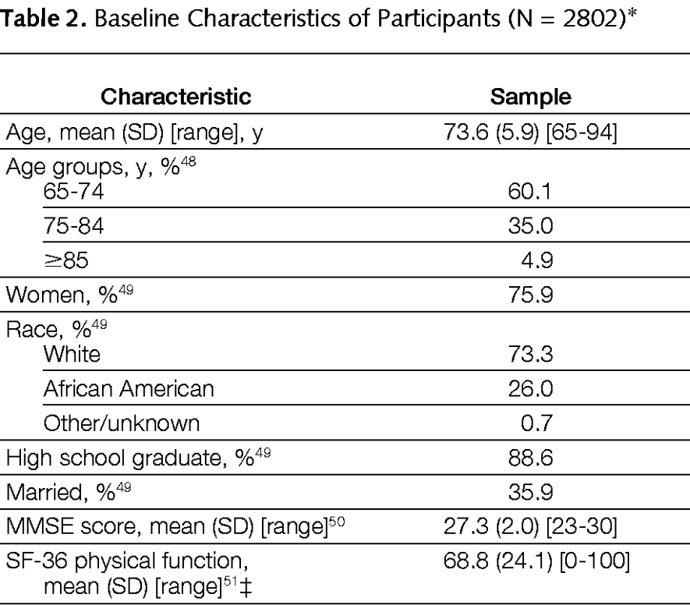

-Does the table show descriptive or inferential statistics? How do you know?
-Pick one variable from the table and discuss the statistics associated with it.

E. Answer the questions based on the table below: (2 points, 1 for each question)
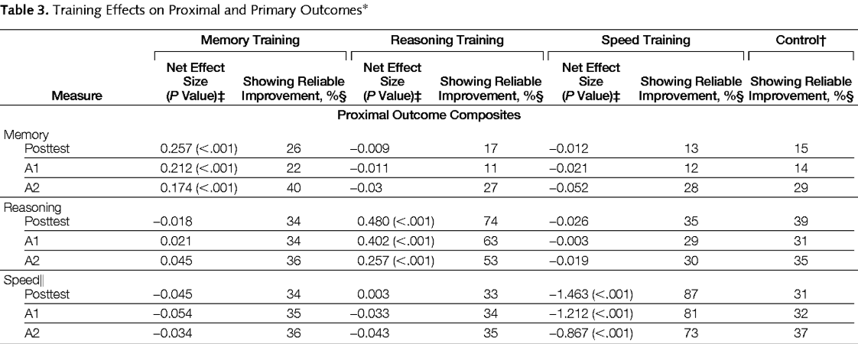

-Which part of the table shows inferential statistics? How do you know?
-Pick one variable from the table and discuss the finding from the inferential statistics associated with it.

